



**Information Security(CSE-411)**

**Submitted to:**

**Dr Safiul Alam Khan**

**Institute** of **Information & Technology**

**University** of **Dhaka**

**Submitted by:**

**Mahir Faisal**

**Roll: 1316**

**Institute** of **Information & Technology**

**University** of **Dhaka**

**Q1 :** **Perform an IP range scan, e.g., 192.168.10.1-254.**

I have performed this task for two different IP address and got two different solutions.

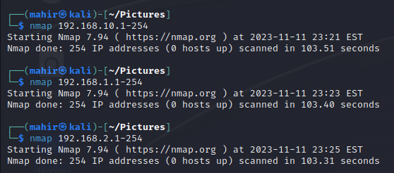

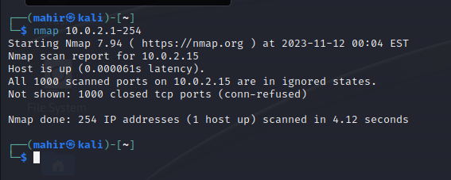

**Q2: Conduct a scan to identify only the live IP addresses within a network.**

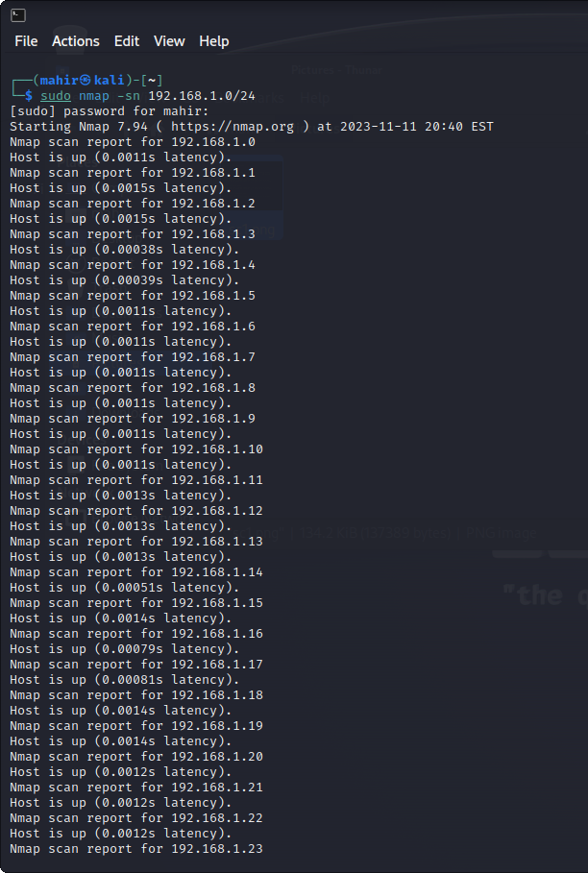

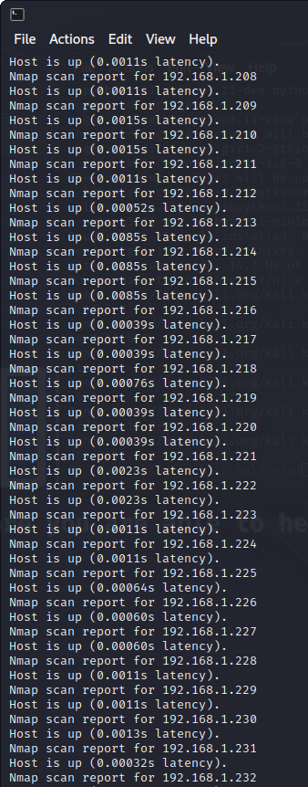

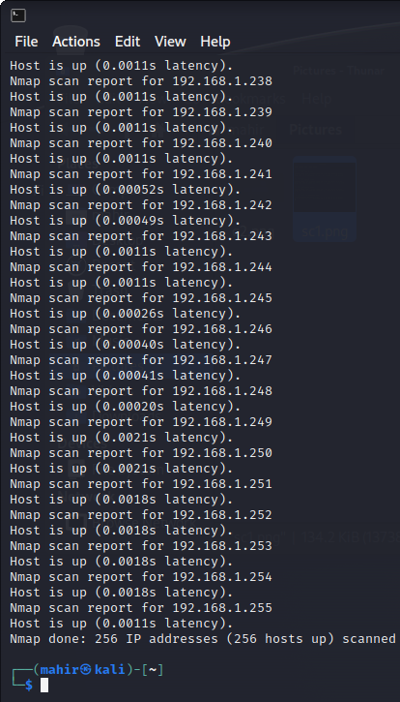

**Q3:**

**Website :** [**http://www.bfcb.gov.bd**](http://www.bfcb.gov.bd)

**a) Scan for open ports along with application version detection**

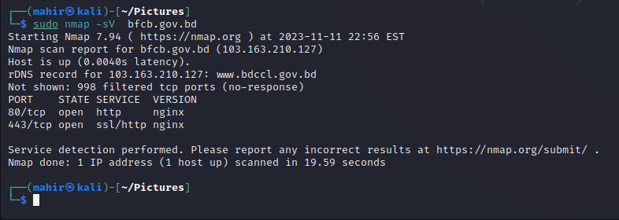

**b) Conduct an OS version scan.**

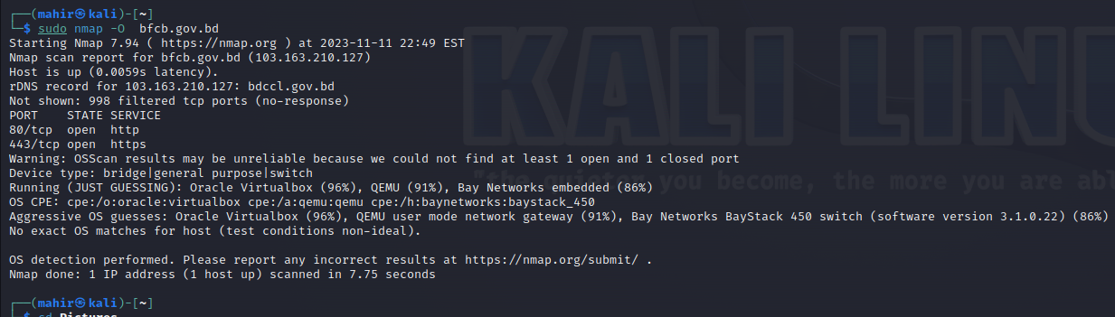

**c) Perform a scan with scripts to create a sitemap of a website**

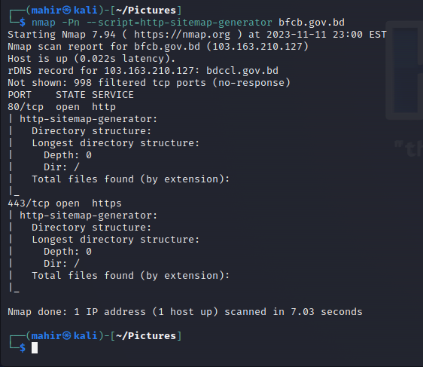

**Website :** [**http://www.blri.gov.bd**](http://www.blri.gov.bd)

1. **Scan for open ports along with application version detection**

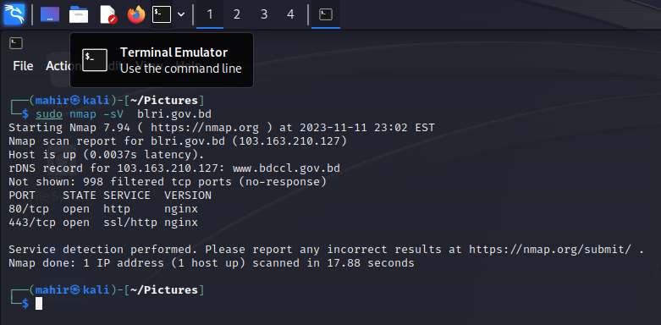

**b) Conduct an OS version scan.**

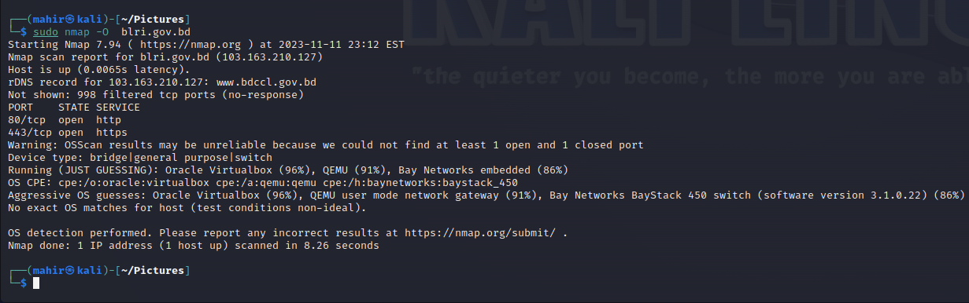

**c) Perform a scan with scripts to create a sitemap of a website**

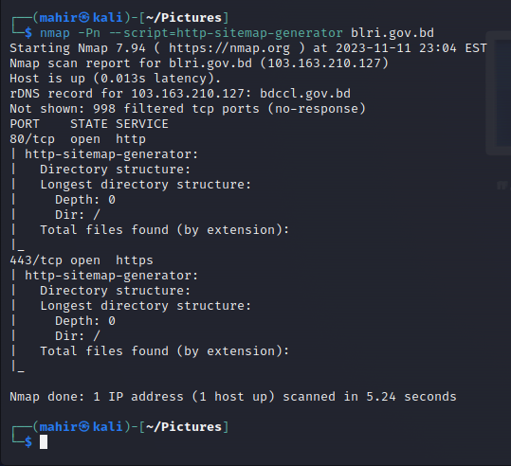

**Website :** [**https://www.molwa.gov.bd**](https://www.molwa.gov.bd)

1. **Scan for open ports along with application version detection**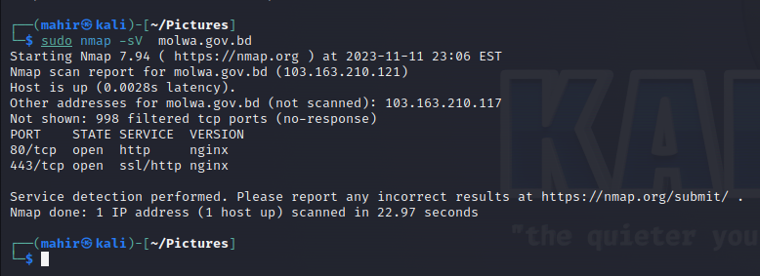

**b) Conduct an OS version scan.**

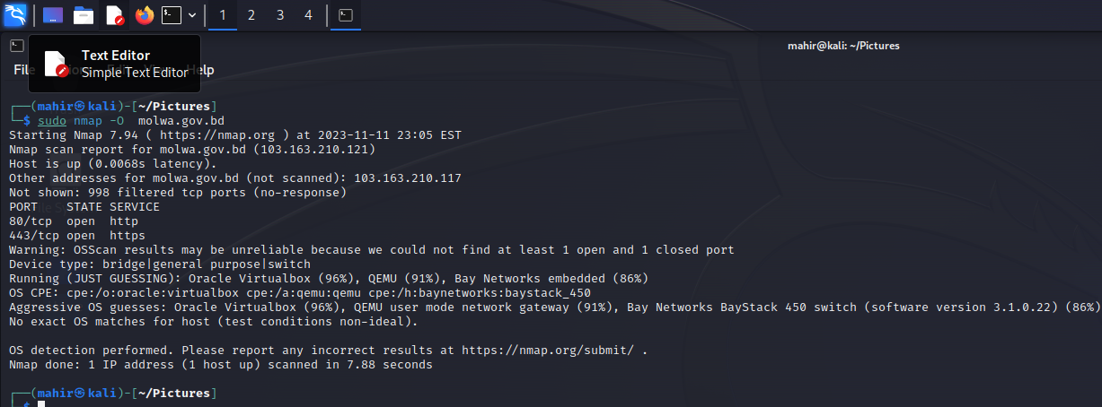

**c) Perform a scan with scripts to create a sitemap of a website**

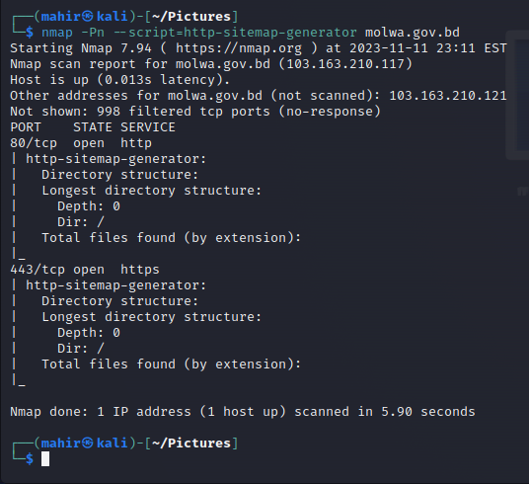

**Website :** [**http://www.bcic.gov.bd**](http://www.bcic.gov.bd)

1. **Scan for open ports along with application version detection**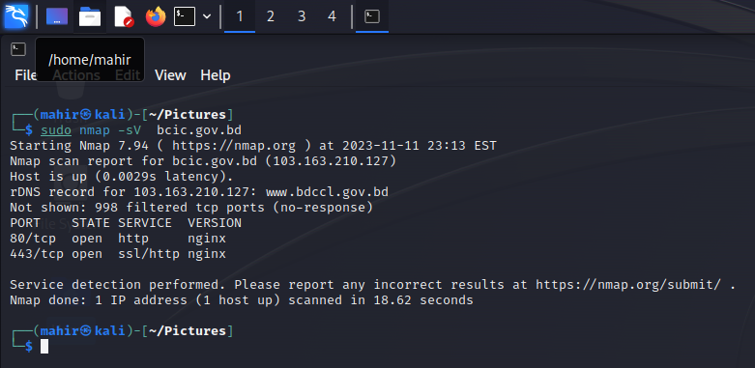
2. **Conduct an OS version scan**

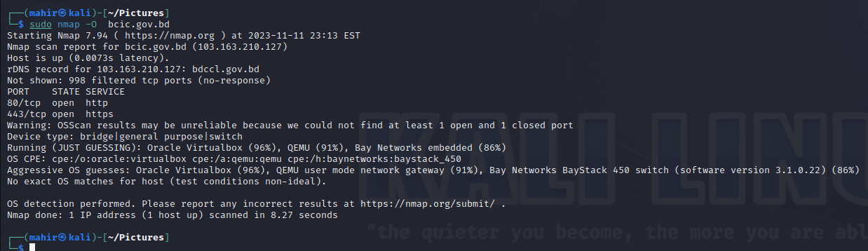

**c) Perform a scan with scripts to create a sitemap of a website**

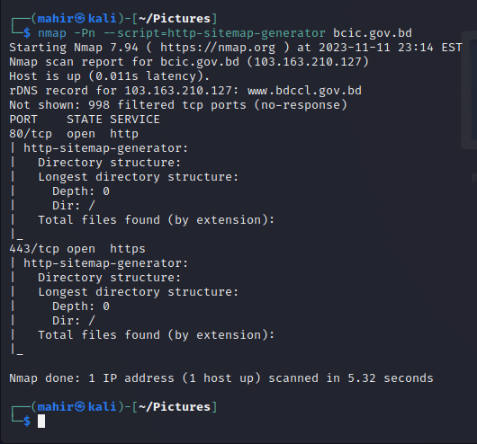

**Website :** [**http://www.wewb.gov.bd**](http://www.wewb.gov.bd)

1. **Scan for open ports along with application version detection**

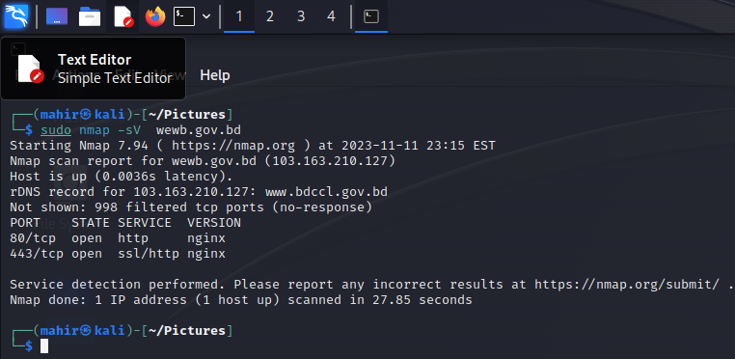

1. **Conduct an OS version scan**

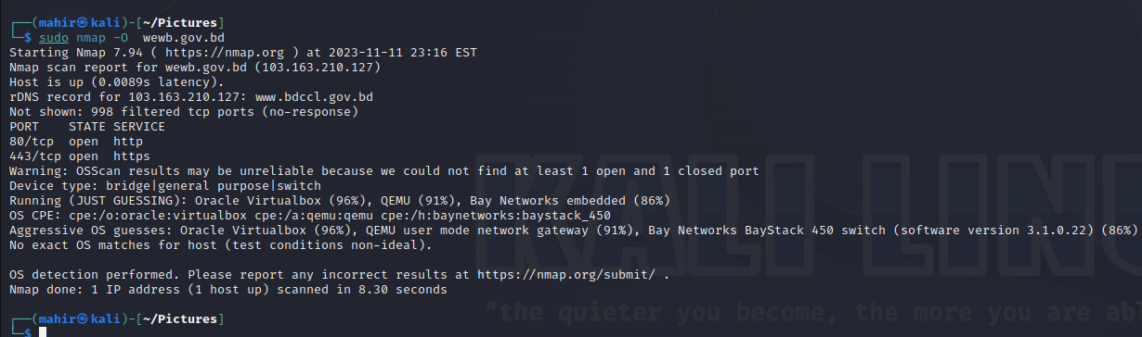

1. **Perform a scan with scripts to create a sitemap of a website**

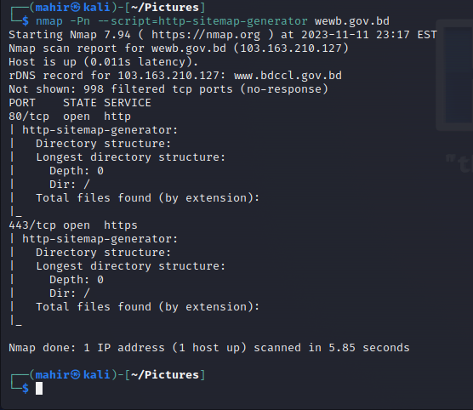

**Website :** [**http://www.brta.gov.bd**](http://www.brta.gov.bd)

1. **Scan for open ports along with application version detection**

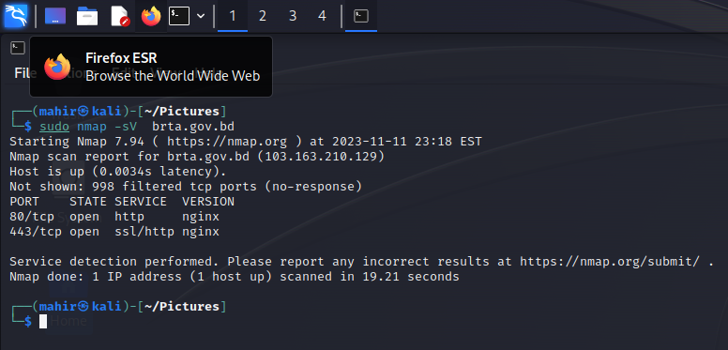

1. **Conduct an OS version scan**

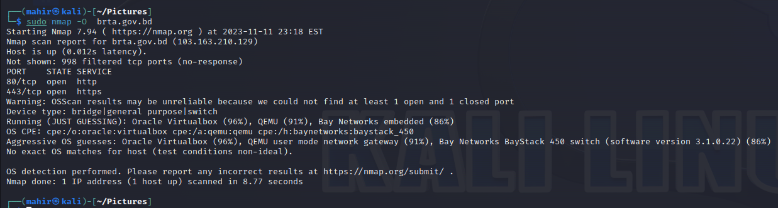

1. **Perform a scan with scripts to create a sitemap of a website**

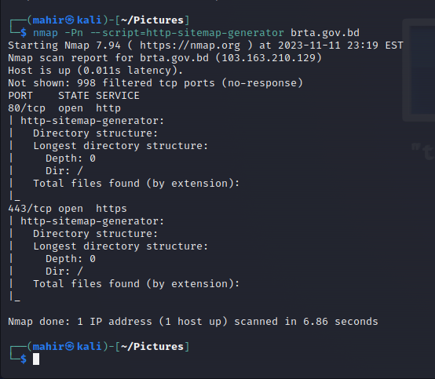

**Comparison :**

|  |  |  |  |  |  |
| --- | --- | --- | --- | --- | --- |
| **bfcb**  (website) | **blri** | **molwa** | **bcic** | **wewb** | **brta** |
| 103.163.210.127  (Reported Ip) | 103.163.210.121  (Reported Ip) | 103.163.210.127  (Reported Ip) | 103.163.210.127  (Reported Ip) | 103.163.210.127  (Reported Ip) | 103.163.210.129  (Reported Ip) |
| nginx  (version) | nginx  (version) | nginx  (version) | nginx  (version) | nginx  (version) | nginx  (version) |
| Orcl v.box(96%)  Qemu(91%) | Orcl v.box(96%)  Qemu(91%) | Orcl v.box(96%)  Qemu(91%) | Orcl v.box(96%)  Qemu(91%) | Orcl v.box(96%)  Qemu(91%) | Orcl v.box(96%)  Qemu(91%) |
| 80/tcp  443/tcp  (port) | 80/tcp  443/tcp  (port) | 80/tcp  443/tcp  (port) | 80/tcp  443/tcp  (port) | 80/tcp  443/tcp  (port) | 80/tcp  443/tcp  (port) |
| http  ssl/http  (service) | http  ssl/http  (service) | http  ssl/http  (service) | http  ssl/http  (service) | http  ssl/http  (service) | http  ssl/http  (service) |